### Introduction

This project is a desktop-based application developed using Windows Forms (WinForms) and follows the MVC (Model–View–Controller) architecture. It is designed to manage student records, courses, timetables, and exams efficiently.

The goal is to offer a user-friendly interface and centralized data management using SQLite, tailored for educational institutions or training centers.

### Objective

To create a robust and scalable system that helps manage academic records.

- To separate the user interface (UI), business logic, and data access layers using MVC pattern.

- To improve usability with real-time validation and error handling.

### Technologies Used

Technology Description

C# Programming Language

WinForms GUI for desktop application

SQLite Lightweight embedded database

.NET Framework for application runtime

Visual Studio IDE used for development

AI Code Development

# Introduction

Acknowledgment

**Table of Contents**

Introduction 1

Problem Definition 2

Ghfgjhfy 2

fgnfgjjr 2

References 7

Table 1: Test case TS01 5

Figure 1: Usecase Diagram 4

# Architecture – MVC Pattern

Model: Handles data-related logic. Includes database connection and operations using SQLite.

- View: Represents the GUI (Windows Forms) where users interact.

- Controller: Manages application logic and acts as a link between the model and view.

### Key Modules

1. User Management

- Add new users

- Update and delete user data

- Login authentication

2. Course Management

- Add/Edit/Delete courses

- Assign course to batch

3. Timetable Management

- Schedule classes

- Prevent overlapping time slots

4. Exam Management

- Assign exam for courses And subject

- Record and manage exam schedules

6. Features

- Clean, form-based GUI

- Full CRUD operations (Create, Read, Update, Delete)

- Data validation with alerts

- Overlap detection for timetable

- Modular code using MVC principles

- Persistent storage using SQLite

7. Sample Code Highlights

// Example: Delete Course (Controller)

using (var conn = DataBasecon.GetConnection())

{

var cmd = new SQLiteCommand("DELETE FROM Add_Table WHERE AddId = @Id", conn);

cmd.Parameters.AddWithValue("@Id", Id);

cmd.ExecuteNonQuery();

}

8. Challenges Faced

- SQLite `database is locked` error due to parallel access

- Foreign key syntax and constraint enforcement

- Implementing MVC in WinForms environment

- Handling overlapping time slots efficiently

9. Future Enhancements

- Add Massage (Massage Send Student/lecturer/staff ,reply )

- Future improvements include implementing biometric-based attendance, generating automated attendance reports, and integrating real-time notifications for absentees.

- Export reports in PDF/Excel(Allow exporting student records, exam results, and attendance in PDF/Excel formats.)

- Add online syncing with cloud database(Migrate from local SQLite to cloud-based databases for real-time data access.)

- Implement responsive UI design with modern styles(Redesign the application with a mobile-friendly, modern UI look.)

-Role-Based Access Control(Implement distinct views and permissions for Admin, Staff, Students, and Lecturers.)

-Real-Time Notifications(Send alerts for exam schedules, attendance shortages, and timetable changes.)

10. Conclusion

The project successfully demonstrates the use of MVC in a WinForms application for managing academic processes. It is scalable and can be enhanced for real-world deployment with minor improvements.

11. Screenshots (To Be Attached)

- try catch AND N/A

- New Users Add ( Users Id Save Users_Table)

- Input Check(Validate)

- Upon form initialization, the entered data is seamlessly integrated and utilized across all applicable components of the system."

Screenshot 01

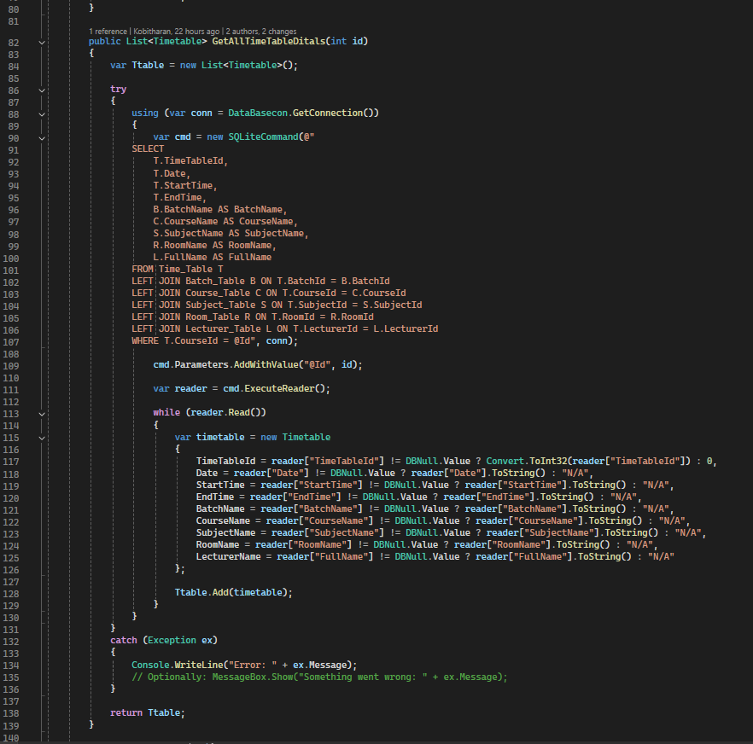

Screenshot 02

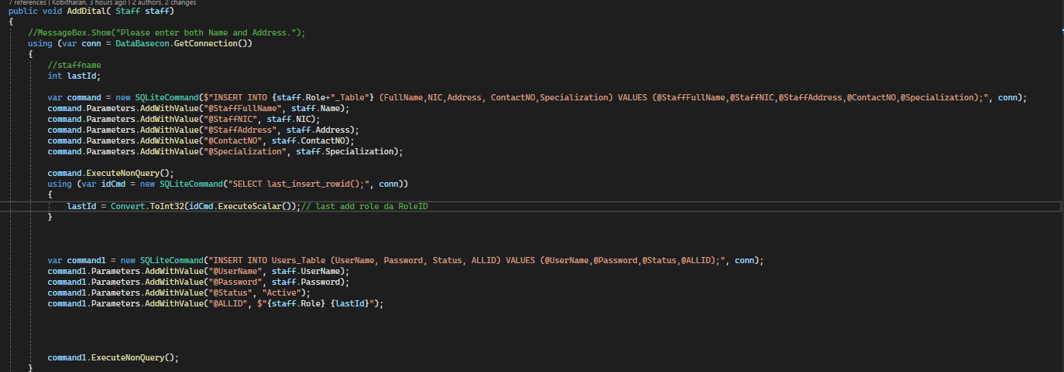

Screenshot 03

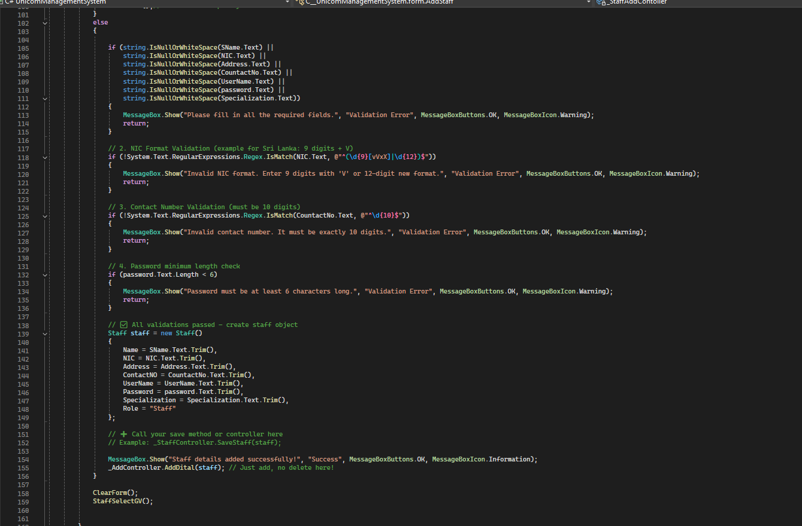

Screenshot 04

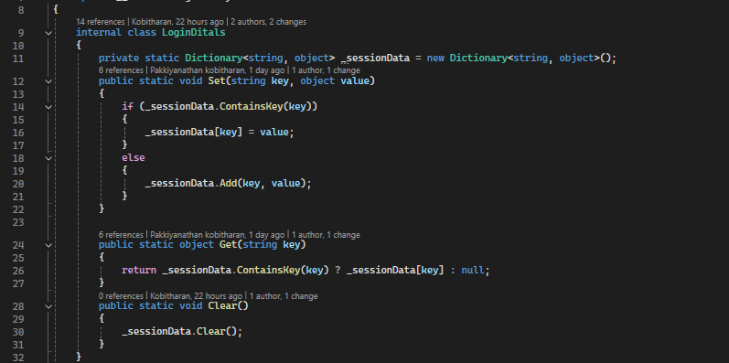

# References

dfg. (2025, 06 15). *rgtery*. Retrieved from erye: efrgrthht